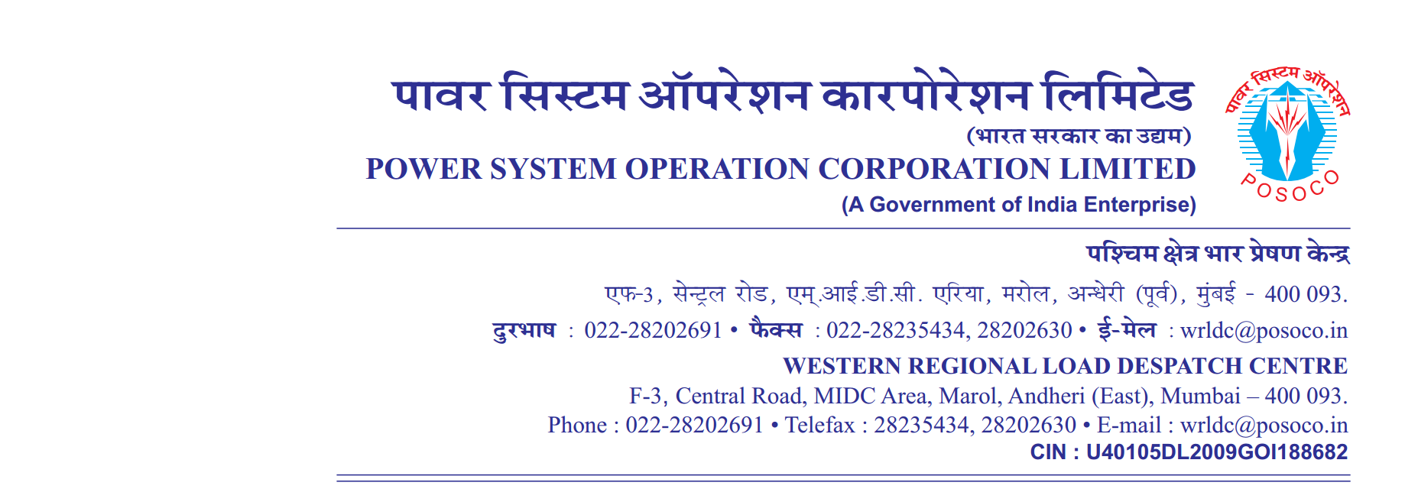

**साप्ताहिक विवरण**

Weekly Report **वर्ष** / सप्ताह संख्या **अवधि**  **से**

Year / Week No Period from to

1. (**आवृति रूपरेखा**) Frequency Profile

|  |  |  |  |  |  |  |  |  |  |  |
| --- | --- | --- | --- | --- | --- | --- | --- | --- | --- | --- |
| **दिनांक** | **अधिकतम तात्कालिक** | **न्युनतम तात्कालिक** | **औसत** | **% of time 49.9**  **से कम** | **% of time 49.9 से 50.05 तक** | **% of time 50.05 से उपर** | **Percentage of Time Frequency Remained outside IEGC Band** | **No’s of hours frequency remained outside IEGC Band** | **FDI =No. of hours out of IEGC band/24Hrs** | **Weekly FDI =No. of hours out of IEGC band/24*7Hrs** |
| **Date** | **Maximum Inst.** | **Minimum Inst.** | **Average** | **<49.9** | **49.9 – 50.05** | **>50.05** | **(Hours)** |
|  | **(Hz)** | **(Hz)** | **(Hz)** | **(%)** | **(%)** | **(%)** | **(%)** |  |
| 17 | 50.24 | 49.76 | 50.02 | 5.75 | 64.83 | 29.42 | 35.17 | 8.44 | 0.35 | 0.26 |
| 18 | 50.18 | 49.72 | 49.97 | 20.43 | 65.86 | 13.72 | 34.14 | 8.19 | 0.34 |
| 19 | 50.19 | 49.79 | 49.99 | 8.38 | 80.72 | 10.9 | 19.28 | 4.63 | 0.19 |
| 20 | 50.18 | 49.71 | 49.99 | 12.75 | 70.5 | 16.75 | 29.5 | 7.08 | 0.29 |
| 21 | 50.16 | 49.82 | 49.99 | 5.19 | 82.55 | 12.27 | 17.45 | 4.19 | 0.17 |
| 22 | 50.16 | 49.72 | 49.99 | 10.0 | 74.77 | 15.23 | 25.23 | 6.06 | 0.25 |
| 24 | 50.21 | 49.77 | 50.0 | 5.73 | 78.02 | 16.25 | 21.98 | 5.28 | 0.22 |